Journal of Engineering and Technological Sciences

Title of Paper

First Author^{1,2}, Next Author¹, Last Author^{2,*} (Use full name for all Author(s))
¹Author Address
²Author Address

*Corresponding author: Email Address

Abstract. Use 9 pt Calibri font for the body text with one/single line spacing, and 12 pt spacing for the next heading. Left and right indent 0.5cm. Maximum length 350 words.
Keywords: use 9 pt; lower case; italic; Times; write alphabetically in 5-10 words.

Page Layout, Style and Formatting
For section titles, use 13 pt, bold, Calibri, title case, with 6 pt spacing before the body text. Use Calibri 10 pt for the body text with single line spacing, 12 pt spacing between paragraphs, and 18 pt spacing before the next heading. To apply this style throughout the manuscript, simply use this template and follow the instructions below.
For this template use the custom margin in Page Layout menu: Top 2 cm, Left margin are 3 cm, Bottom is 2 cm and Right is 1.25 cm. Gutter position is Left. Orientation page is Portrait.
The styles used in this paper are:
- Title, for paper’s title
- Author, for author’s name
- Address, for author’s address
- Abstract, for abstract
- Heading 1, for section title
- Heading 2, for sub section title
- Heading 3, 4, 5, 6, 7, 8, 9 for the next sub … sub-section title
- Text, for body text
- Equation and Enumeration
- Figure, for figure caption
- Table, for table caption
- Reference, for references
- Acknowledge, for References and Acknowledgement header.

This template is already set for the paper in style and formatting, so you can use those styles by typing the style name in the Style box as shown in the figure below:
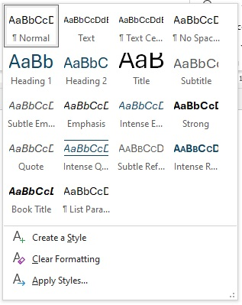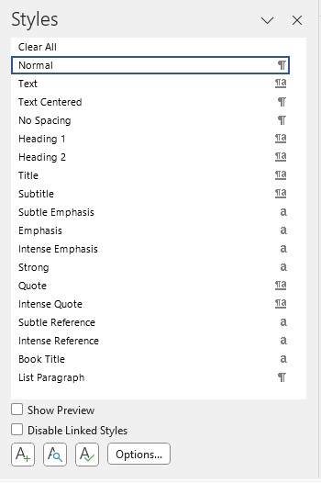

Mathematical Formulation
Equations should be typed with indent 1.27 pt, and numbered consecutively starting with (1) set flush right. To set the style, type Equation in the Style box, or from Style Menu. But this style only sets the tab stop position. To put the equation to the right just press the Tab button one time. And to type the equation number, press the Tab button once again from the right side of the equation.
$x^{2}+y^{2}=z^{2}$ (1)
For numbering, use ordered numbers (1), (2), (3), and so on. Do not order by Chapter i.e (1.1), (1,2), (1,3). For refering an Equation in the body text, please use “Eq. (1)”.

Section and Sub-Section Title
Just type Heading 1 for section title, heading 2 for sub section title, and Heading 3 for sub sub-section title. The number will set automatically.

Figures and Tables
All figures and tables should be centered and numbered consecutively. Use the Figure and Table styles for each figure and table description, respectively. All fonts within figures should be in Calibri, size 9 pt.
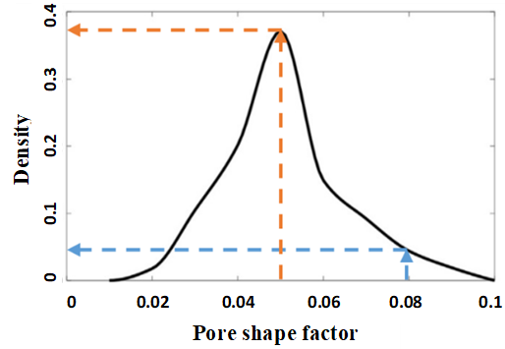
- Type Figure in the style box. The caption should be typed in lower case. Choose center if the caption fit on one line.

Length
The maximum length of article is 25 pages, including all pictures, tables, nomenclature, references, etc.

Title in Odd Page Header
Shorten the title of paper to a maximum of 50 characters from the full title to appears in every header of odd pages, use 11 pt size Calibri font

Manuscript Content
The contents of the paper should be in the following order:

Introduction
The Introduction should provide a comprehensive overview of relevant existing research (state of the art) to establish the current knowledge base. It should clearly identify gaps or limitations in the research, justifying the study's contribution to novelty and showing why further investigation is necessary. Additionally, a clear purpose statement is essential, outlining the study’s objectives and intended contributions to ensure readers understand its direction and significance.

Materials and Methods
The Materials and Methods section outlines the research design, data collection, and analysis methods, ensuring transparency and reproducibility. It describes the sampling approach, study population, and inclusion criteria, as well as data collection tools like surveys or experiments. Analytical techniques are also detailed, showing how data was interpreted. This section allows readers to understand the process and assess the study's validity.

Results
The Results section presents the study's findings clearly and objectively, supported by data, tables, and figures. It addresses each research objective, highlighting key outcomes, patterns, and trends. Quantitative results include statistical analysis, while qualitative data are summarized for essential insights. This section provides the factual basis for the following discussion, ensuring readers can understand the study’s contributions.

Discussion
The findings should be presented clearly, complete with relevant data and facts. They should also be related to previous concepts to establish continuity with existing knowledge. A thorough and in-depth interpretation of the results is essential to provide meaningful insights. Additionally, comparisons with the work of others should be included, along with proper citations to acknowledge prior research and enhance the credibility of the analysis.

Conclusion
The research must address the stated objectives and produce new findings. It should contribute to the development of theories, postulates, formulas, rules, methods, models, or prototypes.

Nomenclature (if necessary)
List the nomenclature in alphabetical order. List Roman letters followed by Greek symbols followed by subscript and superscripts.
A | = | Amplitude
C_{d} | = | drag coefficient
f_{e} | = | linearization coefficient
K_{i} | = | modification factor
γ | = | wave number
ψ | = | Complex wave number

References
References should follow APA Style. For Mendeley and Zotero users, please use APA Style from the following link: https://csl.mendeley.com/styleInfo/?styleId=http%3A%2F%2Fwww.zotero.org%2Fstyles%2Fapa.
References should use a name-year format, not numbers. Enclose citations in parentheses with authors in upright text, i.e:
“Some results from the experiment were given by Hearn (2003), Wijaya and Riyanto (2019), Wijaya, et al., (2020)”
Note that for works with three or more authors, only the last name of the first author is cited, followed by 'et al.'
In the References section, use the same typeface as the main body of the text, or select 'Reference' in the Styles window. References should be listed in alphabetical order.

Acknowledgement
If necessary, you can type your acknowledgement here.

Conflicts of Interest
All authors should disclose in their manuscript any financial or other substantive conflict of interest that might be construed to influence the results or interpretation of their manuscript.

References

Arya, R., Riyanto, E., & Irwan, I. (2023). Title of Paper. Name of Journal, 156, 101971. (Journal)
Awasthi, R., Singh, F., Tripathi, L.,... & Savena, S. (2020). Title of Paper. Name of proc, 26, 3058-3070. (Conference Proceedings)
Brown, C. (2019). Title of Report (Publication No.). Publisher. DOI or URL. (Technical report with report number)
Camil, R., & Warzy, M. (Eds). (2018). Title of book. Publisher. (Book with paper title and editor)
Lowrie, W., & Williams, N. (2020). Title of book. Publisher. (book)
Milley, S. (2018). Title of Thesis/Dissertation. (Publication No. if present) [Doctoral dissertation/Doctoral thesis/Master's dissertation/Master's thesis, Institution Name]. Database Name. URL. (Thesis or Dissertation)
Zabrey, C. (2019, December 12) Title of web page. Name of Website. URL. (URL Link)

